Purpose & Scope
To establish a documented procedure for the processing of orders and to ensure production processes directly affecting process/product quality are carried out under controlled conditions in the warehouse, meeting all “flow-down” requirements stated on paperwork to meet customers’ delivery expectations.

Procedure Statements
  - Customer Order Requirements
  - Industrial Metal Supply paperwork defines the customer order requirements and typically includes the following information: product requirements, process requirements and appropriate specifications, standards and drawings.
  - Flow-Down Requirements are the transfer and translation of special requirements in addition to the PO from our customer to be incorporated in our order. Such as Domestic Only or packaging, surface finish, or any other exception that may apply as shown on customer supplemental terms and conditions of acceptance.
    - Industrial Metal Supply Company Processing includes Band Sawing, Shearing, and Precision Sawing, Circle Sawing, Chop Sawing, Abrasive sawing, and Iron Working.
    - Paperwork is reviewed by Shift Supervisor, Lead or Warehouse Administrator for correctness and clarity before they are assigned to Material Handlers.

Procedure Statements
  - Scheduling
  - Production employees are assigned by the Shift Supervisor to specific work responsibilities for which they meet training requirements.
  - Industrial Metal Supply operates up to three shifts, which are organized and supervised to process orders.
  - When shifts process orders, they need to make sure that all steps are performed consistently and when the order paperwork is completed:
    - All paperwork should be together, with all information on the order.
    - Persons working on the order should sign in the appropriate spot.
    - Record appropriate measurements on paperwork and in Business System
    - Record Pack numbers, Heat numbers, pieces, weights.

Incoming Deliveries of Material
  - Receiving processing incoming material per QSP 10.1, which includes noting incoming information on paperwork and forwarding to the Shipping Office when action has been taken.
  - When material does not arrive on the date due for a “Hold for Incoming” Order, Receiving notifies the Buyer and requests an updated Due Date. If requested by the Buyer, the paperwork may be forwarded to the Buyer.
  - Updated due dates are recorded on the paperwork and is then filed according to that date in Receiving files.

Equipment
  - The equipment used to process customer requirements is specifically selected and approved by management. If a current process needs to be altered and the product / process would be altered, approval from Shift Supervisor or Warehouse Manager is required.
  - The equipment used to process customer requirements is specifically selected and approved by management. Installation and operation are verified by the Vendor at time of purchase. Qualification is signified by signature.
  - Process operation and qualification of machines occurs with the requirement to perform first piece inspection.
  - The maintenance mechanic responds to verbal work requests or to requests submitted via the Maintenance Work Request form, MR001.
  - Preventive maintenance of equipment is performed per QSP 9.5.

Risks
Incomplete Technical Data / Specifications.
Missing order deadline due to poor turn-around-time.
Oversight of flow-down of customer requirements.
Customer-requested changes during processing.
Time constraints for employees to process material
Lack of Preventive maintenance.
Unplanned equipment breakdown.
Improperly / inadequately trained personnel.
Unplanned absenteeism.

Reference Documents

QSP 9.5 Maintenance of Equipment
QSP 10.1 Receiving Inspection
QSP 10.3 Loading and Final Shipping Inspection .
QSP 15.1 Product Handling, Storage and Preservation
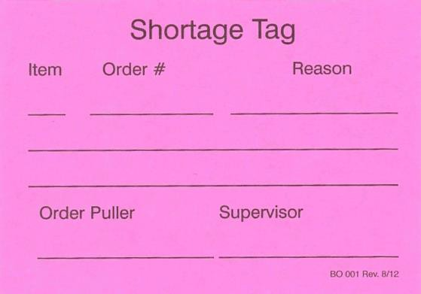
QSI 9.1.6 Packaging

Applicable Records

Shortage Tag
BO001 Maintenance/Repair Request MR001

Personnel to be Trained.
Warehouse Personnel

